IT8761- SECURITY LABORATORY

CEASER CIPHER

ENCRYPTION AND DECRYPTION

Gurram Venkata Bala Sai Yaswanth

111517104041

A-Section

IVth YEAR

AIM : To Perform Encryption and Decryption using Ceaser Cipher.

DEFN: A ceaser cipher is a simple method of encoding messages. Caesar ciphers use a substitution method where letters in the alphabet are shifted by some fixed number of spaces to yield an encoding alphabet. A Caesar cipher with a shift of 1 would encode an A as a B, an M as an N, and a Z as an A, and so on.

**Encryption Algorithm:**

#include<stdio.h>

int main()

{

char msg[100], ch;

int i,key;

printf("Enter a plaintext \n");

scanf("%s",msg);

printf("Please Enter a key to create a secret message :)-\n");

scanf("%d",&key);

for(i=0;msg[i]!='\0';i++)

{

ch=msg[i];

if(ch>='a'&&ch<='z')

{

ch=ch+key;

if(ch>'z')

{

ch=ch-'z'+'a'-1;

}

msg[i]=ch;

}

else if(ch>='A'&&ch<'Z')

{

ch=ch+key;

if(ch>'Z')

{

ch=ch-'Z'+'A'-1;

}

msg[i]=ch;

}

}

printf("The Encrypted message is--> %s", msg);

printf("\n");

return 0;

}

**OUTPUT:**

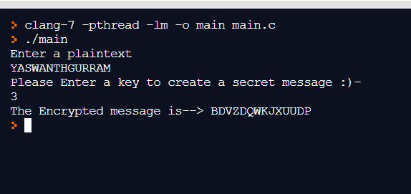s

From the given output :

The plain text was YASWANTHGURRAM

KEY=3

The Encrypted message was changed as: BDVZDQWKJXUUDP

Y🡪B

A🡪D

S🡪V

W🡪Z

A🡪D

N🡪Q

T🡪W

H🡪K

G🡪J

U🡪X

R🡪U

R🡪U

A🡪D

M🡪P

#include<stdio.h>

int main()

{

char msg[100], ch;

int i,key;

printf("Please enter the Encrypted text :) \t");

scanf("%s",msg);

printf("Enter Your key to decrypt the message\t");

scanf("%d",&key);

for(i=0;msg[i]!='\0';i++)

{

ch=msg[i];

if(ch>='a'&&ch<='z')

{

ch=ch-key;

if(ch<'a')

{

ch=ch+'z'-'a'+1;

}

msg[i]=ch;

}

else if(ch>='A'&&ch<'Z')

{

ch=ch+key;

if(ch<'A')

{

ch=ch+'Z'-'A'+1;

}

msg[i]=ch;

}

}

printf("Your Decrypted message is--> %s", msg);

return 0;

}

DECRYPTION ALGORITHM

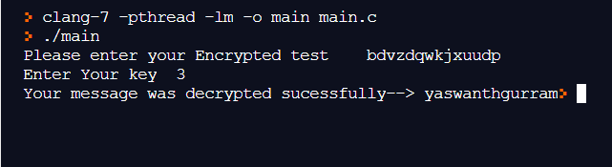

**OUTPUT:**

Encrypted Test: bdvzdqwkjxuudp

Key: 3

Decrypted test was: yaswanthgurram

**RESULT:** The program Encryption and Decryption in Ceaser Cipher Executed Sucessfully.